No.0477 - 2023: Fifth Session, Sixth Legislature

GAUTENG PROVINCIAL LEGISLATURE

========================

ANNOUNCEMENTS,
TABLINGS AND
COMMITTEE REPORTS

========================

Wednesday, 06 December 2023

ANNOUNCEMENTS
none

TABLINGS
none

COMMITTEE REPORTS
1. The Chairperson of the Transport and Logistics Portfolio Committee, Hon. G D Schneemann, tabled the Committee’s Final Voting Mandate on the Economic Regulation of Transport Bill [B1D-2020] Section 76 as well as the Minority Report, as attached:

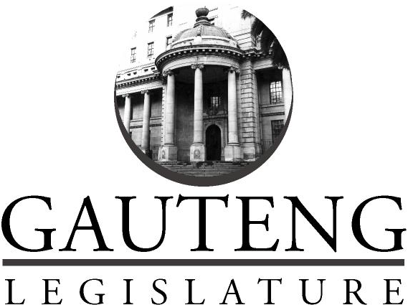
PORTFOLIO COMMITTEE ON TRANSPORT AND LOGISTICS

FINAL VOTING MANDATE ON
ECONOMIC REGULATION OF TRANSPORT BILL [B1D-2020]

(Section 76)

05 December 2023
- INTRODUCTION
The Chairperson of the Portfolio Committee on Transport and Logistics (“the Committee”),
Hon G. Schneemann, hereby tables the Committee’s Final Voting Mandate on the Economic Regulation of Transport Bill [B1D-2020].

PROCESS FOLLOWED
The Speaker of the Gauteng Provincial Legislature, Hon Ntombi Mekgwe referred the further Amendment on Economic Regulation of Transport Bill [B1D-2020] to the Portfolio Committee on Transport and Logistics for consideration and reporting in terms of Rule 245 (1) read with 246 (1), 247 and 248 on Friday, 01st December 2023.

On Tuesday, 05th December 2023, the Committee convened a meeting to deliberate further amendments and minutes from the NCOP Select Committee on Transport, Public Service and Administration, Public Works and Infrastructure and adopt the Final Voting Mandate on Economic Regulation of Transport Bill [B1D-2020].

- FINANCIAL IMPLICATIONS
The financial implications in relation to executing these duties will be absorbed and budgeted for internally once this body is operational.

- COMMITTEE’S RECOMMENDATIONS

In terms of section 65 of the Constitution, read with section 6 and 8 of the Mandating Procedure of provinces Act 52 of 2008 as well as Rule 248 of the Gauteng Provincial Legislature Standing Rule, The Portfolio Committee on Transport and Logistics confer authority on the Gauteng Provincial Delegate/s to National Council of Provinces to vote in favour of the Economic Regulation of Transport Bill [B1D-2020].

Gauteng Provincial Legislature
Roads and Transport Committee

MINORITY REPORT

Submitted in terms of Rules 162(2) and 162(4) of the Gauteng Legislature Standing Rules by
Members
EP Du Plessis (MPL)
FP Nel (MPL)
On the voting mandate for the Economic Regulation of Transport Bill 2020.

- INTRODUCTION
In terms of rule 162(2) the Gauteng Provincial Legislature standing rules a minority report may be submitted to a portfolio committee when a matter is considered and there is a substantial disagreement on a policy issue on the matter being considered.
Members EP du Plessis and FP Nel from the Democratic Alliance, the official opposition in the Gauteng Legislature, opposes the committee voting mandate on the Economic Regulation of Transport Bill 2020. Given the fact that the members represents the official opposition it suffices as substantial disagreement and thus meets the first standard for submission of a minority report.
The policy issues on which the members disagree with the rest of the committee is discussed below.

- OBJECTIVES OF THE BILL
The Economic Regulation of Transport Bill seeks to establish a new entity under the National Department of Transport to regulate competition and prices within the public transport sector. The goal of this new creation as a potential new additional entity is to combine the specific function of pricing determination among all the existing entities in transportation. Theoretically, this would entail the function of all tariffs, fees, permits, and other charges across the spectrum of entities in transportation—covering road, rail, aviation, and maritime—being extracted from current entities like SANRAL (toll-fees), C-BRTA (permits), SAPorts (tariffs), etc. to then operate jointly under the supervision of a regulator in control of all transportation costs.

- OBJECTIONS TO THE BILL

The following are the main reasons why the members concerned are objecting to the bill and thus opposes the voting mandate to support it.
Regarding this Bill, the quality of the legislative drafting is woefully inadequate. The Bill is fundamentally at odds with South Africa's legal and constitutional framework as well as with economic reality. Price controls, which make up the bulk of the Bill, are bad for a thriving economy and will inevitably distort incentives and market forces.
The proposed Bill is seen to have three major problems at its core.

- The Bill expands the extent and potential reach of government meddling in the transportation industry, invading the private domain without justification and without need.
- The Bill is clearly intended to centralise governmental power away from civil society and away from independent institutions, in the hands of the Department of Transport and its minister.
- The Bill grants executive officials, most notably the Minister of Transport and the proposed Regulator, discretionary powers that are not constrained by any guiding criteria on how they must exercise those powers.
Section 1(c) of the Constitution's guarantee of the Rule of Law states that Parliament must abstain from giving the executive unchecked discretionary authority while enacting laws. The Bill, however, is replete with clauses that provide the Minister and the Regulator unchecked ability to make judgments based solely on their whims, assign officials to specific positions, and give specific instructions to specific individuals. Due to the Bill's unclear language, some ambiguous clauses allow for the Minister and Regulator to apply them anyway they see proper.
Provided the Minister of Finance’s recent interim medium term budget policy statement and the imperative to cut wasteful entities and rationalise functions within the public service, the creation of a new entity will work against this objective stated by the minister. It is also unknown what the additional financial burden on the Gauteng Provincial Budget will be once this entity is established. This is a risk to the province as it is likely that the provincial budget faces cuts in the medium term.
It is the members’ considered view that the functions envisaged in the bill is sufficiently addressed by the Competition Commission and internally within the various departments of transport and that the establishment of a separate entity that will duplicate functions is not necessary. We support that the status quo be retained and that the various departments of transport ensure market based competition in the public transport sector through closer cooperation with the Competition Commission.

- CONCLUSION
The above reasons explicitly motivates why the members of the official opposition opposes the voting mandate on the Economic Regulation of Transport Bill 2020 and proposes to the House to reject support for this bill.

END.

