No.0475 - 2023: Fifth Session, Sixth Legislature

GAUTENG PROVINCIAL LEGISLATURE

========================

ANNOUNCEMENTS,
TABLINGS AND
COMMITTEE REPORTS

========================

Tuesday, 05 December 2023

ANNOUNCEMENTS
none

TABLINGS
none

COMMITTEE REPORTS
1. The Chairperson of the Oversight Committee on the Premier’s Office and the Legislature (OCPOL), Hon. B W Dhlamini, tabled the Committee’s Report on the Gauteng Laws General Amendment Bill [G007-2020], as attached:
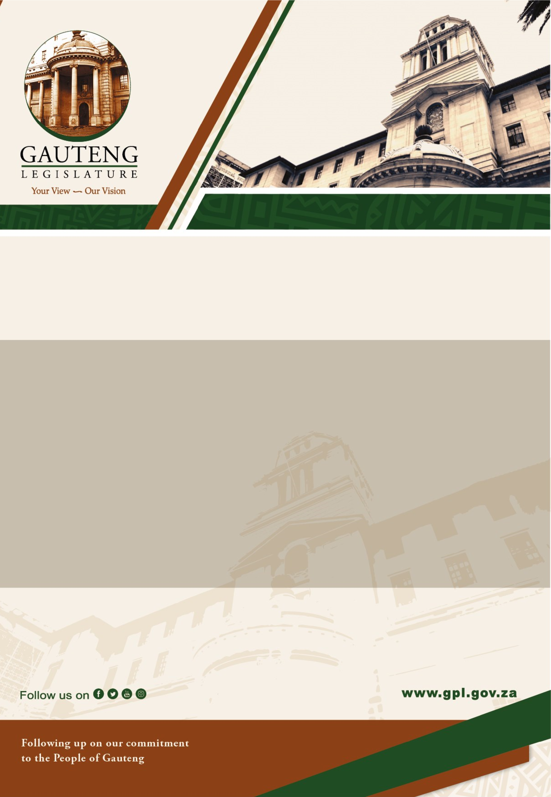

OVERSIGHT COMMITTEE ON THE PREMIER’S OFFICE
AND THE LEGISLATURE
Report on

GAUTENG PROVINCIAL LAWS GENERAL
AMENDMENT BILL [G007-2020]

-

30th November 2023

On behalf of the Chairperson of the Oversight Committee on the Premier’s Office and the Legislature, Hon. BW Dhlamini; the Hon. Member ST. Msimanga tables the Committee's report on the Gauteng Provincial Laws General Amendment Bill [G007-2020] as follows:

1. Introduction

The Gauteng Provincial Laws General Amendment Bill [G007-2020] is a Provincial Government Bill introduced at the Gauteng Provincial Legislature in terms of Rule 192(1) of the Standing Rules of the Gauteng Provincial Legislature, Version 5 – Revision 8).

The objectives of the Bill include rationalizing the appointment or reappointment of members of boards and the hiring of chief executive officers of provincial public entities. The amendments that the Bill sought to make were technical and administrative in nature as the focus was mainly powers conferred to the Executive Council (as opposed to the MEC) in recruiting and appointing Board Members, Chairpersons, Deputy Chairpersons, as well as CEOs. The amendments further highlighted the powers conferred to the Executive Council in dissolving the Board, terminating membership, terminating the role of CEOs and filling vacancies of Board Members, or setting up Interim Boards.

2. PROCESS FOLLOWED

2.1 The Gauteng Provincial Laws General Amendment Bill, [G007- 2020] was formally referred to the Oversight Committee on the Office of the Premier and Legislature (herein referred to as the ‘OCPOL’) for consideration, deliberation, and reporting by the Speaker of the Gauteng Provincial Legislature Hon L Mekgwe on 10th May 2022.

2.2 The Bill was presented to the Committee on Tuesday, 25th October 2022 by the Premier’s Office. This presentation was followed by a Research Analysis on the potential socio-economic impact which might emanate from the Bill. The NCOP and Legal Unit also, provided the legal opinion on the Bill.

2.3 In accordance with Rule 197(1)(3)(4)(a) (C) (d)the Standing Rules of the GPL, the Bill was published in the Government Gazette for general information and public inputs.

2.4 As required by legislation, the Committee conducted public hearings to solicit stakeholders’ submissions on the Bill. Public hearings were conducted as follows:
- Thursday, 09th November 2022 at the Gauteng City Hall, Johannesburg.
- Friday, 03rd November 2023 at Sunnyside Park Hotel & Conference Centre, Parktown, Gauteng.

  - At the public hearings, written and oral submissions were received from various stakeholders amongst others: Business Regulation & Governance in the Department of Economic Development; Gauteng Liquor Board, G-fleet, Consumer Affairs Board; South African Law Reform Commission; National Consumer Tribunal, as well public representatives from Eersterust, Sebokeng, West Rand, Tshwane, Ekurhuleni, and Vaal.

  - On Thursday, 30th November 2023, the Committee deliberated on and adopted its draft report on the Bill.

3. | Committee Position

The Oversight Committee on the Premier’s Office and the Legislature supports the Gauteng Provincial Laws General Amendment Bill [G007-2020] with amendments.

4. Principle of the Bill

The Bill sought to make 68 amendments within the 7 Acts listed below. The affected Acts includes:
- The Gauteng Gambling Act, 1995
- The Consumer Affairs (Unfair Business Practices Act), 1996
- The Gauteng Tourism Act, 2001
- The Gauteng Growth and Development Agency (Proprietary) Limited Act, 2003
- The Gauteng Enterprise Propeller Act, 2005
- The Gautrain Management Agency Act, 2006
- The Gauteng Liquor Act, 2014

5. Details of the Bill

Clause 1, 2,3 4, 5, 6, 8, and 10 respectively provides for the amendment of section 5,6,8,10,12, 12A, 14,18B, 18C and 84 of the Gauteng Gambling Act, 1995 (Act No. 4 of 1995) and was adopted as introduced.

Clause 7 and 9 provides for the amendment of section 5,6,8,10,12, 12A, 14,18B, 18C and 84 of the Gauteng Gambling Act, 1995 (Act No. 4 of 1995) and was adopted with amendments.

Clause 11 to 13 respectively provides for the amendment of section 1, 14, and 29 of the Consumer affairs (Unfair Business Practices) Act, 1996 (Act No. 7 of 1996) and was adopted as introduced.

Clause 14, 15, 17, 18 and 19 respectively provides for the amendment of section 5, 5A, 5C, 5D. 6 and 11of the Gauteng Tourism Act, 1996 (Act No. 5 of 2001) and was adopted as introduced.

Clause 16 provides for the amendment of section 5, 5A, 5C, 5D. 6 and 11of the Gauteng Tourism Act, 1996 (Act No. 5 of 2001) and was with amendments.

Clause 20 provides for the amendments of section 8 of the Gauteng Growth and Development Agency (Proprietary) Limited Act, 2003 (Act No. 5 of 2003, and was adopted as introduced.

Clause 21 to 27 respectively provides for the amendment of section 7, 9, 10, 20, 22, 24 and 33 of the Gauteng Enterprise Propeller Act, 2005 (Act No, 5 of 2005) and was adopted as introduced.

Clause 28 to 33 respectively provides for the amendment of section 10, 12, 13, 23 25 and 29 of the Gautrain Management Act, 2006 (Act No. 5 of 2006) and was adopted as introduced.

Clause 34, 35, 36 and 38 respectively provides for the amendment of section 2, 3, 7, 8 and 74 of the Gauteng liquor Act, 2014 (Act No. 3 of 2014) and was adopted as introduced.

Clause 37 provides for the amendment of section 2, 3, 7, 8 and 74 of the Gauteng liquor Act, 2014 (Act No. 3 of 2014) and was adopted with amendments.

Clause 39 provides for the short title and commencement of the Bill and was adopted with amendments.

5. Constitutional and Legal Implications

The Committee is of the view that the Bill, as tabled by the Office of the Premier is within the constitutional framework of the Republic of South Africa.

5.1 Socio – Economic Impact

As per the Explanatory Memorandum to the Bill, there are no envisaged social implications.

5.2 Financial Implications
The Bill highlighted that out of the proposed 68 amendments, there are no material socio-economic impact; as a result, no additional financial obligations will be imposed on the Gauteng Provincial Government; except for the current economic impact derived from the different principal Acts.

6. Acknowledgements
The Oversight Committee on the Office of the Premier and Legislature, hereby thanks and acknowledges the co-operation of the Office of the Premier and the role played by the Gauteng Premier, Hon. P Lesufi, the Director-General, Mr E. Mosuwe and the team of Senior Officials.

The Hon. Chairperson, BW Dhlamini, wish to thank the following OCPOL Members: LE Makhubela; F Hassan; D. Ledwaba; B. Masuku; T. Munyai; ST. Msimanga; J. Bloom; A. Fuchs; R Makwala; L Masilela; DK Adams; and A. Alberts, for their diligence and commitment during this process.

Furthermore, the Committee would like to thank the following Committee Support Staff for their dedication and support: Group Committee Co-ordinator, M Vaas; Senior Committee Co-ordinators, B Makgato and N Montisi; Senior Researcher, N Dlamini; Committee Researcher, O Mogole; Committee Administrators, E Sonny and X Sithole; Information Officer, A Netshivhuyu; Hansard Recorder, N Zondo; Service Officer, M. Katisi and Communication Officer, S. Simelane; Proceedings Unit, Mr Ralph Chiloane and Advocate Senkokile, NCOP & Legal Unit, Mr Shakespear Ncube, for their dedication and commitment in the finalization of the Bill.

7. Adoption

After due deliberations, the Committee adopt the report on Gauteng Provincial Laws General Amendment Bill, [G007- 2020]. In accordance with Rule 163 read together with 164 the Committee presents the report to the House and recommends its adoption.

